JIMMA UNIVERSITY



JIMMA UNIVERSITY INSTITUTE

OF TECHNOLOGY

FACULTY OF COMPUTING AND INFORMATICS

PROGRAM: -DEPARTMENT OF COMPUTER SCIENCE

SECTION -2

**GROUP ASSIGNMENT ARTIFICIAL INTELLIGENCE**

**TITLE: -COMPUTER VISION AND IMAGE PROCESSING**

**NAME ID NO**

1. **WOGARI FAYERA …………………………………......RU2975/11**
2. **NAGASO ADUGNA …………………………………….RU2828/11**
3. **YOBSAN KUMA…………………………………………RU3085/10**
4. **SARA GEMEDA…………………………………………RU0812/10**

**Submitted to mr.Dessalegn**

**Jimma, Ethiopia**

**May 11, 2022**

# Contents

1. Computer vision and image processing 1

1.1 Definition of Computer Vision 1

Figure 1.1: computer vision in artificial intelligence 1

1.2 Origin of Computer Vision 1

1.3 Importance of Computer Vision 2

1.4 Ways of learning Computer Vision 3

1.5 Suited Language for Computer Vision 3

1.6 Applications of Computer Vision 4

1.7 Computer Vision Challenges 5

2. What is Image Processing? 5

2.1 Essential Steps in Digital Image Processing 6

2.2 Computer Vision in image processing 10

Figure 2.1: - Image enhancement technique. 6

Figure 2.2: - Image restoration 7

Figure 2.3:- Wavelet transformation. 7

Figure 2.3: - Image Compression. 8

Figure 2.4: - Morphological operation results. 9

Figure 2.5: - Segmentation of regions according to color values, shapes, and textures. 9

Figure 2.6: Example of tagging/labeling of image. 10

Summary 12

# Computer vision and image processing

## 1.1 Definition of Computer Vision

Vision is “to know what is where, by looking.’’

* Where?
* What?

CV is a science that deals how computer can be made to gain high-level of understanding from the digital image or video. From engineering point of view it seeks to automate the tasks performed by human vision system. It concerns about the theory how artificial systems can extract information from images. CV studies and describes the processes implemented in software and hardware behind the artificial vision systems.

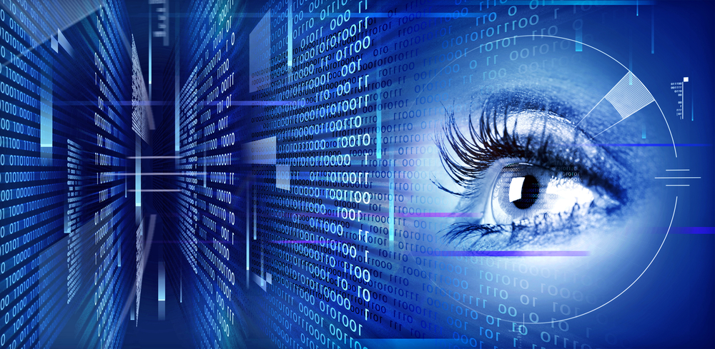Computer vision is a field of study which enables computers to replicate the human visual system. It’s a subset of [artificial intelligence](https://www.mygreatlearning.com/blog/what-is-artificial-intelligence/) which collects information from digital images or videos and processes them to define the attributes. The entire process involves image acquiring, screening, analyzing, identifying and extracting information. The main objective of this branch of [artificial intelligence](https://www.mygreatlearning.com/blog/top-10-hot-artificial-intelligence-technologies/) is to teach machines to collect information from

### Figure 1.1: computer vision in artificial intelligence

## 1.2 Origin of Computer Vision

Computer vision is not a new concept; in fact, it dates back to the 1960s. It all started with an MIT project - “Summer Vision Project” which analyzed scenes to identify objects. David Marr, the celebrated neuroscientist and the father of computer vision laid down the [building blocks of computer vision](https://www.mygreatlearning.com/blog/deep-learning-computer-vision/), taking a cue from the functions of the cerebellum, hippocampus, and cortex of human perception. Examples of Computer Vision and Algorithms: - Automatic cars aim at reducing the need for human intervention while driving, through various AI systems. [Computer vision](https://www.mygreatlearning.com/blog/deep-learning-computer-vision/) is part of such a system which focuses on imitating the logics behind human vision to help the machines take data-based decisions.

**The way in Which Computer Vision Works**

Computer vision works by trying to mimic the human brain’s capability of recognizing visual information. It uses pattern recognition algorithms to train machines on a large amount of visual data. The machine/ computer then processes input images, labels the objects on these images, and finds patterns in those objects.

While machine learning algorithms were previously used for computer vision applications, now deep learning methods have evolved as a better solution for this domain. For instance, machine learning techniques require a humongous amount of data and active human monitoring in the initial phase monitoring to ensure that the results are as accurate as possible.

## 1.3 Importance of Computer Vision

Computer vision helps in computing world by teaching machines to “see” these images and videos. Computer vision also ensures moderation and monitoring of online visual content. One of the main tasks involved in online content cu ration is indexing. Since the content available on the internet is mainly of two types, namely text, visual, and audio categorization becomes easy. [Computer vision uses algorithms](https://www.mygreatlearning.com/blog/deep-learning-computer-vision/) to read and index images. Popular search engines like Google and YouTube use computer vision to scan through images and videos to approve them for featuring. By way of doing so, they not only provide users with relevant content but also protect against online abuse and “toxicity”.

Computer vision can help the world in various ways:

* Unmanned aerial vehicles for delivering supplies in emergency scenarios.
* Facial recognition for security at public places and military applications.
* Optical character recognition for processing text.
* Gesture recognition to raise red flags against miscreants in public places.
* Disaster control.

## 1.4 Ways of learning Computer Vision

**Laying the Foundation:**Probability, statistics, linear algebra, calculus and basic statistical knowledge are prerequisites of getting into the domain. Similarly, knowledge of programming languages like Python and MATLAB will help you grasp the concepts better.

**Digital Image Processing:**Learn how to compress image and videos using JPEG and MPEG files. Knowledge of basic image processing tools like histogram equalization, median filtering and more are required. Once you know the basics of image processing and restoration, you will be ready to pick up the more critical skills of computer vision.

**Machine Learning Basics:**Knowledge of [Convoluted Neural Network](https://www.mygreatlearning.com/blog/cnn-model-architectures-and-applications/)s, fully connected neural networks, support vector machines, recurrent neural networks, generative adversarial network, and auto encoders are necessary to get started with computer vision.

**Basic Computer Vision:**The next step in the process is to decode the mathematical models involved in the image and video formulations. Once you understand how pattern recognition and signal processing works, you can get into advanced learning.

## 1.5 Suited Language for Computer Vision

We have several programming language choices for computer vision – Open CV using C++, Open CV using Python, or MATLAB. However, most engineers have a personal favorite, depending on the task they perform. Beginners often pick Open CV with [Python for its flexibility](https://www.mygreatlearning.com/blog/python-tutorial-for-beginners-a-complete-guide/). It’s a language most programmers are familiar with, and owing to its versatility is very popular among developers.

**Python with Computer vision**

Computer vision experts recommend Python for the following reasons:

* **Easy to Use:** Python is easy to learn, especially for beginners. It is one of the first programming languages learnt by most users. This language is also easily adaptable for all kinds of programming needs.
* **Most Used computing language**: Python offers a complete learning environment for people who want to use it for various kinds of Computer Vision and Machine Learning experiments. Its dumpy, sickie-learn, mat plot lib and Open CV provides an exhaustive resource for any computer vision applications.
* **Debugging and Visualization**: Python has an in-built debugger, ‘PDB’ which makes debugging codes in this programming language more accessible. Similarly, Mat plot lib is a convenient resource for visualization.

**Open CV with Computer Vision**

Computer Vision experts also gravitate towards Open CV for the following reasons:

* **Zero Cost:**OpenVMS comes at free of cost and what’s better than saving a little money? You can use it for commercial applications; even check the source for corrections. The most significant advantage of using Open V is that you don’t have to make your project open source.
* **Exhaustive Library:**Open CV has the most extensive collection of algorithms. The transparent API makes Open CL devices compliant on devices and optimizes performance.
* **Platform and Devices:**A number of embedded vision applications and mobile apps prefer Open CV as their vision library of choice for its performance-focused design. You can use it across all platforms and devices.
* **Large Community:**Open CV is used by over 9 million people who are continually updating and helping each other through blogs and forums. A significant advantage of using Open CV is that you will always find support from the community. Since companies like Google, Intel and AMD fund its development, Open CV is evolving fast.

## 1.6 Applications of Computer Vision

* **Medical Imaging:** Computer vision helps in MRI reconstruction, automatic pathology, diagnosis, and machine aided surgeries and more.
* **AR/VR:**Object occlusion (dense depth estimation), outside-in tracking, inside-out tracking for virtual and augmented reality.
* **Smartphones:** All the photo filters (including animation filters on social media), QR code scanners, panorama construction, Computational photography, face detectors, image detectors (Google Lens, Night Sight) that you use are computer vision applications.
* **Internet:** Image search, geo-localization, image captioning, areal imaging for maps, video categorization and more.

## 1.7 Computer Vision Challenges

Human vision is a complicated and highly effective system which is difficult to replicate through technology. However, that’s not to say that computer vision will not improve in the future.

Here are some challenges we face in computer vision:

* **Reasoning Issue:**Modern neural network-based algorithms are complex system whose functioning is often obscure. In situations like these, it becomes tough to find the logic behind any task. This lack of reasoning creates a real challenge for computer vision experts who try to define any attribute in an image or video.
* **Privacy and Ethics**: Vision powered surveillance is a serious threat to privacy in a lot of countries. It exposes people to unauthorized use of data. Face recognition and detection is prohibited in some countries because of these problems.
* **Fake Content:**Like all other technologies, computer vision in the wrong hands can lead to dangerous problems. Anybody with access to powerful data center is capable of creating fake images, videos or text content.
* **Adversarial Attacks**: These are optical illusions for the computer. When an attacker creates a faulty machine learning model, they intend the machine using it to fail. These flawed models are difficult to identify and can cause serious damage to any system.

# What is Image Processing?

Image processing involves two methods, namely analog image processing and digital image processing. Analog image processing comprises the technique to process photographs, printouts, and different hard copies of images. In contrast, digital image processing involves manipulating the digital image for generating information with the help of complex algorithms.

The input for an image processing task is an image. However, it is essential to note that analog image processing always requires an image input. Still, digital image processing may include images or information associated with an image, such as features or bounding boxes, etc. Ideally, image processing is used for the following purposes.

* Image visualization is the representation of the processed data in the form of visual output for better understanding. This task is mainly done for objects that are not easy to detect in an image.
* Improving the quality of the image by using image sharpening and restoration.
* Image search is associated with retrieving the image source from an investigation conducted by an image search engine.
* To perform classification to distinguish different objects and locating their position in an image.

## 2.1 Essential Steps in Digital Image Processing

**1. Image Acquisition**

Typically, image acquisition involves capturing an image by a sensor such as a camera. If a non-digital form of output exists, it is converted to a digital form using an analog to a digital converter. This process also includes pre-processing, such as image scaling.

**2.** **Image Enhancement**

The process that is related to image manipulation to achieve relevant results for specified tasks to be performed is known as image enhancement. Ideally, this process relates to image filtering by performing tasks such as noise removal, contrast adjustment, brightness, and sharpening of the images for improving the quality of the image that were captured originally.

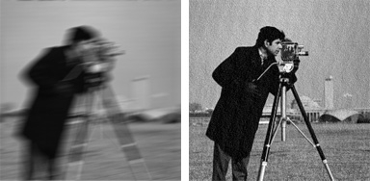

### Figure 2.1: - Image enhancement technique.

**3.** **Image Restoration**

Image restoration involves improving the appearance of an image that may have been degraded by mathematical and probabilistic models. An ideal example would be the reduction of blurring in an image.

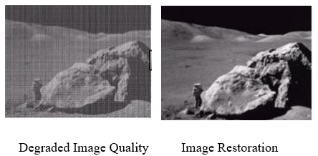

### Figure 2.2: - Image restoration

**4.** **Color Image Processing**: The extraction of features from an image with a color-based approach.

**5.** **Wavelet and Multi-Resolution Processing**

It involves representing images in terms of various resolutions available that is generally used for image compression. This is useful for image data compression as well.

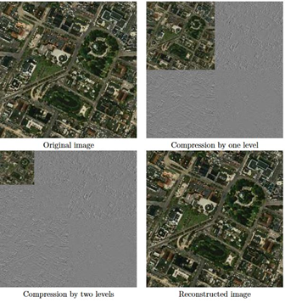

### Figure 2.3:- Wavelet transformation.

**6.** **Compression**

Reducing the storage space required saving an image or the bandwidth required for displaying an image is done with the help of compression. The techniques that involve image size reduction and adjustment such that the quality is least deteriorated falls under the image compression procedure.

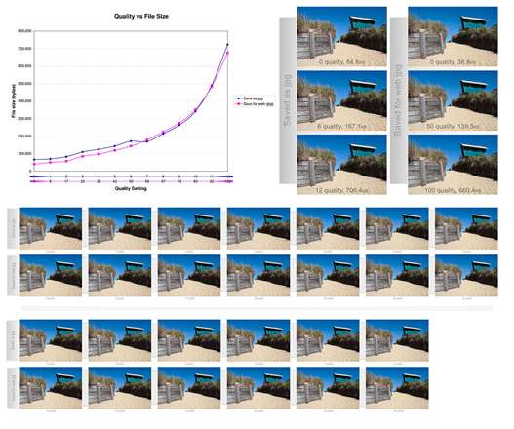

### Figure 2.3: - Image Compression.

**7.** **Morphological processing**

The extraction of essential components in an image describes the shape of a particular object in an image. Some of the typical morphological operations are erosion and dilation for producing image attributes.

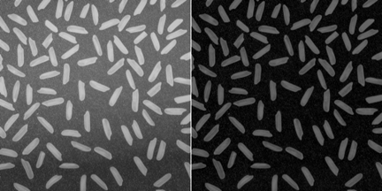

### Figure 2.4: - Morphological operation results.

**8.** **Segmentation**

Image segmentation is one of the necessary procedures under image processing that involves the partitioning of the image into multiple segments. This procedure allows locating objects in an image and identifying the boundaries of the objects. An important point to note is that the segmentation’s accuracy will lead to better recognition and classification accuracy.

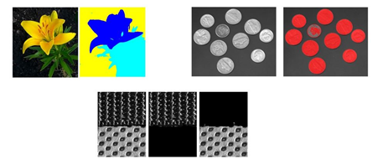

### Figure 2.5: - Segmentation of regions according to color values, shapes, and textures.

**9.** **Representation and Description**

The representation is associated with displaying image output in the form of a boundary or a region. It can involve characteristics of shapes in corners or regional representations like the texture or skeletal shapes. On the other hand, the description is most commonly known as feature selection, responsible for extracting meaningful information from an image. The information extracted can help to differentiate between classes of objects from one another accurately.

**10.** **Object Recognition / Image Labeling**

The process of assigning labels to an object depending on its description for classification purposes. This is a very important step for Computer Vision. To train models, a large enough corpus of images need to be processed and labeled, so that the Computer Vision model can be utilize to detect similar objects in other images.

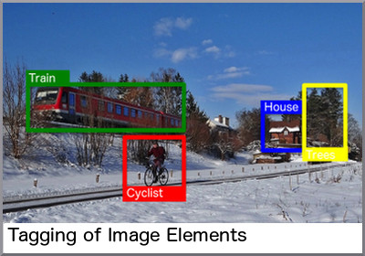

### Figure 2.6: Example of tagging/labeling of image.

## 2.2 Computer Vision in image processing

As described above, Image Processing generally refers to the application of algorithms to images. The purpose of such algorithms is often meant to improve the quality of the image or to alter it for a different visual effect. However, Image Processing is also very important to prepare images for Computer Vision models, such as applying segmentation or labeling known objects.

Computer Vision generally refers to the technologies involved in allowing computers to make sense of images. The most common application of this is image recognition, which is a process that enables the identifying of objects and image features. Image recognition is used in numerous applications today, such as medical imaging, security surveillance, facial recognition, identification of logos, and buildings, to name a few. However, for these models to work, the images need to first be labeled, segmented, or have other processing steps taken as mentioned prior.

Today, Computer Vision applications have achieved tremendous success, and some of the most notable use cases are outlined below:

**Defect Inspection: -**Image recognition has contributed positively to the manufacturing units. The primary task of image recognition has been to identify defective items during the manufacturing process. The ability to quickly examine thousands of defective items in the assembly line speeds up the overall process and leads to efficiency in the mode of operations.

**Image Classification: -**Perhaps, the most crucial part of image recognition that has been part of many types of research is image classification. The possibility of assisting doctors in finding a region of interest for detecting and predicting a particular disease has been part of several researches in recent years. Image classification has been a critical contributor in e-commerce industries to enhance the user experience with quick search possibilities. Image classification allows categorizing images as per specific image content. It is part of most of the recommendation systems and image retrieval engines that we use today.

**Autonomous Driving:-**The state-of-the-art technology of autonomous driving is yet to reach its full potential before being allowed commercially. However, to have pedestrian detection capability and to stop when a stop sign is being shown has been possible to incorporate image recognition into computer vision techniques.

**Robotics: -** Image recognition has been part of many robotics-based projects used to train them to identify objects for better navigation and detect objects that may be found in its path.

**Text Detection: -** Text detection is yet another promising contribution with the help of image recognition. The detection of text and characters from an image such as a photograph that can include a street sign or a traffic sign has been a possibility with text detection. Cloud Vision by Google is one of the prominent companies in the field of text detection.

**Facial Recognition: -** With the emergence of AI, [facial recognition](https://addepto.com/using-artificial-intelligence-ai-for-image-recognition/) has been a possibility. From securing the device to surveillance, facial recognition has a strong demand in the market due to its potential. However, several experts are questioning the privacy aspects of the technology. Nevertheless, it is a fact that every technology has some limitations. Therefore, the proper implementation of facial recognition techniques will result in life essentials, such as traffic and city surveillance.

**E-Commerce: -** Shoppers can now search for similar products by uploading images of existing products they have, or products they want to find complementary styles to. This requires the transformation of the image into a visual embedding, where then the recommendations are either products similar to the one uploaded or the ones known to be complementary.

**Getting Started with Image Recognition Models**

Some of the most valuable packages to utilize for Computer Vision and Image Processing include:

* Inutile
* Open Cv
* Dib
* Sickie-Learn
* Sickie-Image
* Tensor Flow
* Kara’s
* Festal
* Porch Cv

You can also explore prebuilt cloud services by using:

* [Amazon Recognitions](https://aws.amazon.com/rekognition/)
* [Google Cloud Vision AI](https://cloud.google.com/vision)
* [Microsoft’s Cognitive Services Computer Vision](https://azure.microsoft.com/en-us/services/cognitive-services/computer-vision/)

# Summary

* Although perception appears to be an effortless activity for humans, it requires a significant amount of sophisticated computation. The goal of vision is to extract information needed for tasks such as manipulation, navigation, and object recognition.
* The geometry and optics of image formation is well understood. Given a description of a 3D scene, we can easily produce a picture of it from some arbitrary camera position— this is the graphics problem. The inverse problem, the computer vision problem—taking a picture and turning it into a 3D description—is more difficult.
* Representations of images capture edges, texture, optical flow, and regions. These yield cues to the boundaries of objects and to correspondence between images.
* Convolutional neural networks produce accurate image classifiers that use learned features. Rather roughly, the features are patterns of patterns of patterns. It is hard to predict when these classifiers will work well, because the test data may be unlike the training data in some important way. Experience teaches that they are often accurate enough to use in practice.
* Image classifiers can be turned into object detectors. One classifier scores boxes in an image for objectless; another then decides whether an object is in the box, and what object it is. Object detection methods aren’t perfect, but are usable for a wide variety of applications.
* With more than one view of a scene, it is possible to recover the 3D structure of the scene and the relationship between views. In many cases, it is possible to recover 3D geometry from a single view. The methods of computer vision are being very widely applied.